CYART Red Teaming – Week 3 Final Report

Executive Summary
This project demonstrates practical red teaming activities performed in a controlled lab environment using Kali Linux and industry-standard offensive security tools. The engagement included reconnaissance, OSINT collection, vulnerability assessment, phishing simulation, exploitation research, lateral movement analysis, and reporting.
Multiple tools including Recon-ng, Nmap, Shodan, OWASP ZAP, Metasploit Framework, SET Toolkit, PhoneInfoga, and Impacket were used to simulate real-world attacker methodologies mapped to MITRE ATT&CK techniques.
The objective of this project was to understand attacker workflows, document practical findings, and improve defensive awareness through controlled offensive security exercises.

Objectives
- Perform reconnaissance and OSINT collection
- Conduct DNS and WHOIS enumeration
- Perform advanced Nmap scanning
- Identify potential vulnerabilities
- Simulate phishing methodologies
- Study exploitation workflows
- Understand lateral movement techniques
- Document findings professionally
- Maintain Git-based reporting workflow

Lab Environment
Component | Details
Operating System | Kali Linux
Version | Rolling Release
Tools Used | Recon-ng, Nmap, Metasploit, Shodan, OWASP ZAP, SET Toolkit
Repository Management | Git & GitHub
Testing Environment | Controlled Educational Lab

Tools Used
Tool | Purpose
Recon-ng | Reconnaissance and OSINT
WHOIS | Domain registration analysis
DIG | DNS enumeration
Nslookup | DNS resolution
Nmap | Network scanning and service enumeration
NSE Scripts | Vulnerability detection
Shodan | Internet exposed host intelligence
OWASP ZAP | Web application testing
Metasploit Framework | Exploitation research
SET Toolkit | Social engineering simulation
PhoneInfoga | Phone intelligence gathering
Impacket | Lateral movement research

Practical Activities

1. Reconnaissance and OSINT

Objective
Perform domain intelligence gathering and reconnaissance.

Activities Performed
- DNS enumeration using DIG
- Domain analysis using WHOIS
- Nslookup testing
- Recon-ng workspace creation
- Bing domain reconnaissance module execution
- Shodan exposed service research

Commands Used
dig example.com
nslookup example.com
whois example.com
recon-ng

Findings
Target | Result
example.com | DNS records identified
WHOIS | Registrar and nameserver information obtained
Recon-ng | Module execution completed
Shodan | Exposed Apache hosts identified

MITRE ATT&CK Mapping
- T1595 – Active Scanning
- T1593 – Search Open Websites/Domains
- T1046 – Network Service Scanning

2. Advanced Nmap Scanning

Objective
Perform service and vulnerability detection.

Activities Performed
- Service detection scan
- Aggressive scan
- NSE vulnerability scan
- Output logging

Commands Used
nmap -sV -sC scanme.nmap.org
nmap -A scanme.nmap.org
nmap --script vuln scanme.nmap.org

Key Findings
Port | Service | Status
22 | SSH | Open
80 | HTTP Apache | Open
9929 | Nping Echo | Open
31337 | Elite | Open

Vulnerability Findings
Vulnerability | Description
Slowloris DOS | Potential HTTP denial-of-service exposure
HTTP Enumeration | Apache directory information exposed

MITRE ATT&CK Mapping
- T1046 – Network Service Scanning
- T1190 – Exploit Public-Facing Application

3. Vulnerability Assessment

Objective
Perform basic web vulnerability analysis.

Activities Performed
- OWASP ZAP automated scan attempt
- Web enumeration
- Vulnerability identification

Findings
The web testing environment demonstrated possible web attack surfaces and exposed HTTP service information.

Recommendations
- Update Apache services
- Disable unnecessary modules
- Enable security headers
- Restrict exposed directories

4. Metasploit Framework Research

Objective
Study exploitation module workflows.

Activities Performed
- Metasploit installation
- Module loading
- Exploit option review
- Payload analysis

Module Used
exploit/unix/ftp/vsftpd_234_backdoor

Outcome
The exercise demonstrated exploitation framework structure and payload configuration methodology in a controlled environment.

MITRE ATT&CK Mapping
- T1068 – Exploitation for Privilege Escalation
- T1190 – Exploit Public-Facing Application

5. Phishing Simulation

Objective
Understand social engineering methodologies.

Activities Performed
- SET Toolkit execution
- Social engineering menu analysis
- Phishing workflow simulation
- Documentation and screenshot collection

Findings
The phishing simulation demonstrated how attackers may create credential harvesting campaigns through cloned login portals and social engineering techniques.

MITRE ATT&CK Mapping
- T1566 – Phishing
- T1566.001 – Spearphishing Attachment

6. Phone Intelligence Gathering

Objective
Perform OSINT-based phone number intelligence collection.

Activities Performed
- Docker-based PhoneInfoga deployment
- Phone number scan
- Reputation and leak search analysis

Findings
PhoneInfoga successfully generated OSINT references related to the target phone number and demonstrated phone-based reconnaissance capabilities.

7. Lateral Movement Research

Objective
Study remote execution and lateral movement techniques.

Activities Performed
- Impacket installation verification
- PsExec command review
- Remote execution workflow analysis

Tool Used
impacket-psexec

MITRE ATT&CK Mapping
- T1021 – Remote Services

Evidence Collection
The following evidence was collected during the engagement:
- Recon screenshots
- Nmap scan outputs
- Vulnerability scan results
- Shodan screenshots
- SET Toolkit screenshots
- Metasploit outputs
- PhoneInfoga results
- Git workflow evidence

Repository Structure
Logs/
Notes/
Outputs/
Reports/
Screenshots/
Tools/
Workflow/
README.md

Challenges Faced
- Network timeout issues during Recon-ng scanning
- OWASP ZAP target connection limitations
- Package hash mismatch during Metasploit installation
- Slow NSE vulnerability scanning execution

Recommendations
- Continue practicing in controlled lab environments
- Improve phishing simulation workflows
- Study exploit development further
- Build isolated vulnerable virtual machine labs
- Practice reporting and evidence documentation
- Explore blue-team detection using Wazuh or SIEM platforms

Conclusion
This project successfully demonstrated practical red teaming concepts in a controlled and ethical environment. The engagement covered reconnaissance, scanning, vulnerability analysis, exploitation research, phishing simulation, OSINT collection, and lateral movement methodology.
The activities improved understanding of offensive security workflows, attacker techniques, reporting standards, and Git-based documentation practices aligned with industry methodologies and MITRE ATT&CK techniques.

Disclaimer
This project was conducted strictly for educational and authorized laboratory purposes only. No unauthorized systems were targeted during this engagement.

OSINT & RECON PRACTICAL
We will complete:
- Recon-ng
- Whois
- Dig
- Nslookup
- Nmap
- Shodan research
- documentation
- screenshots
- git upload

Install Recon-ng
sudo apt update
sudo apt install recon-ng -y
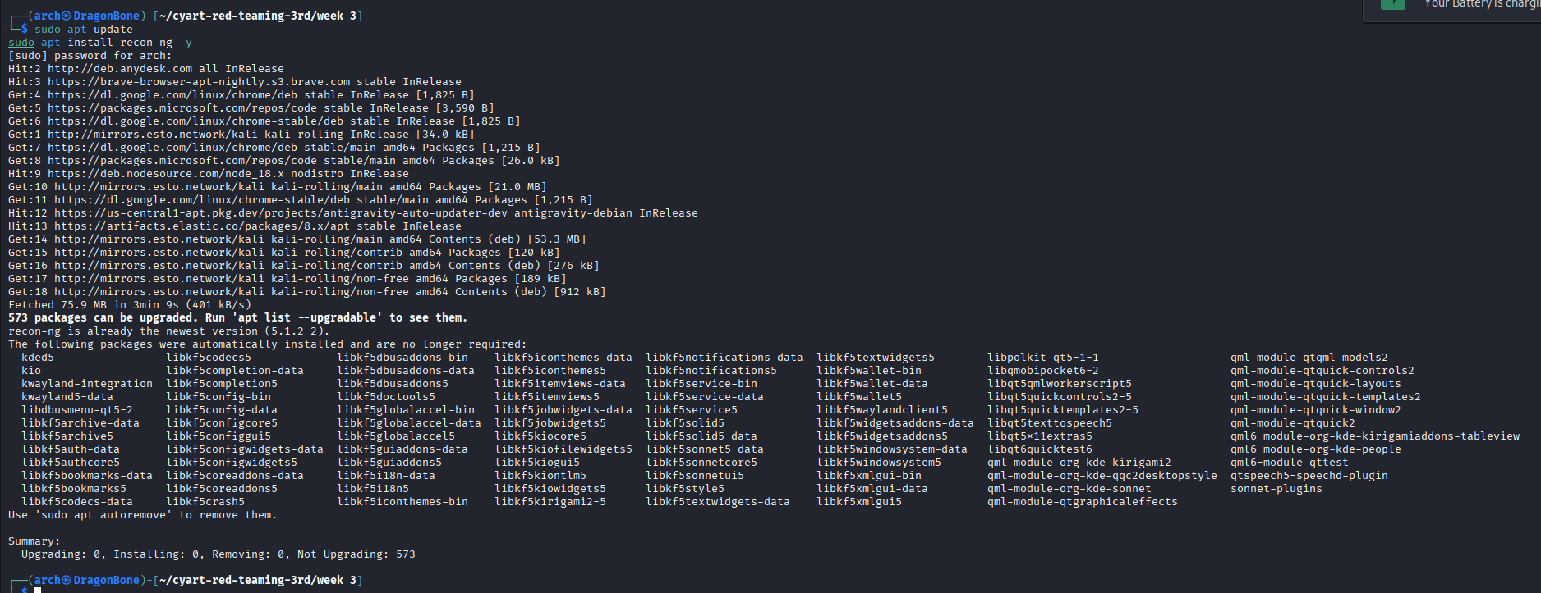

Launch Recon-ng
recon-ng
Inside recon-ng:
marketplace install recon/domains-hosts/bing_domain_web
modules load recon/domains-hosts/bing_domain_web
options set SOURCE example.com
run

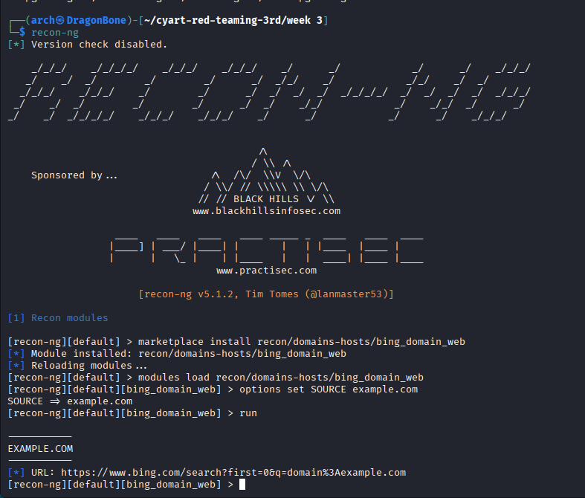

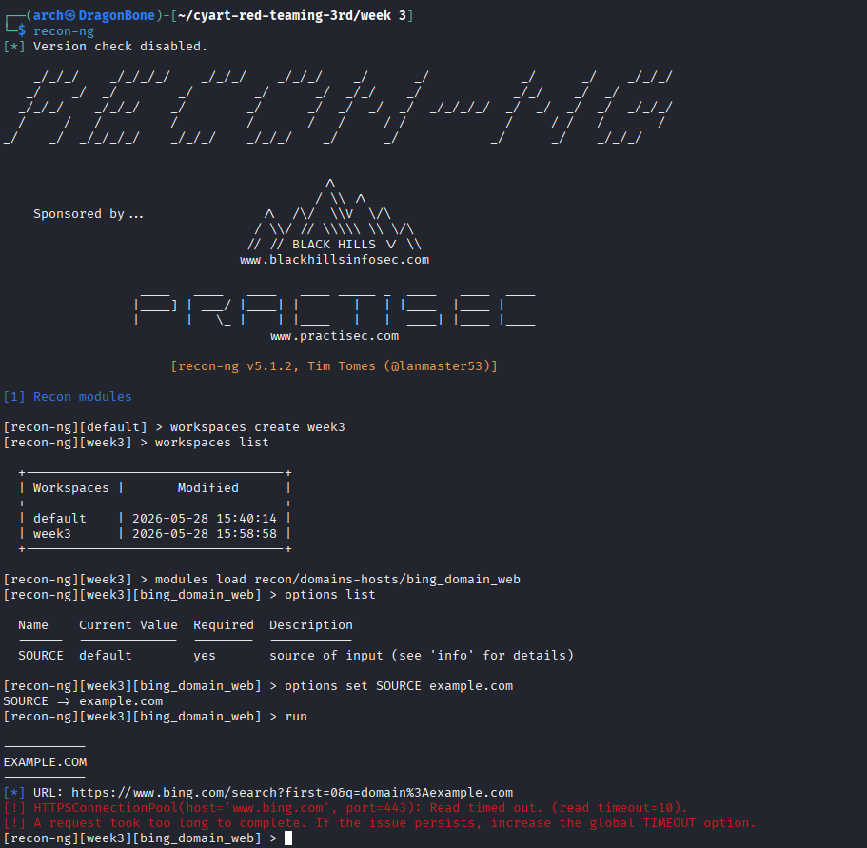
DNS Enumeration:
dig example.com
nslookup example.com

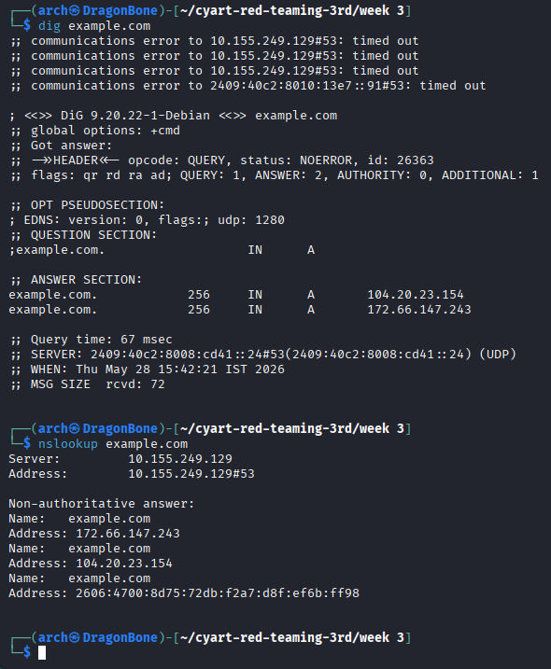

WHOIS Enumeration
sudo apt install whois -y
whois example.com
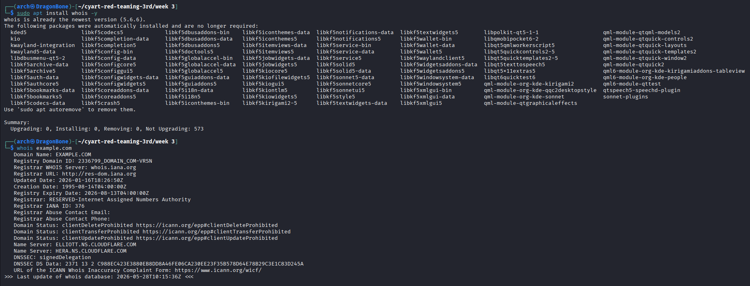

Nmap Scan
sudo apt install nmap -y
nmap -sV example.com

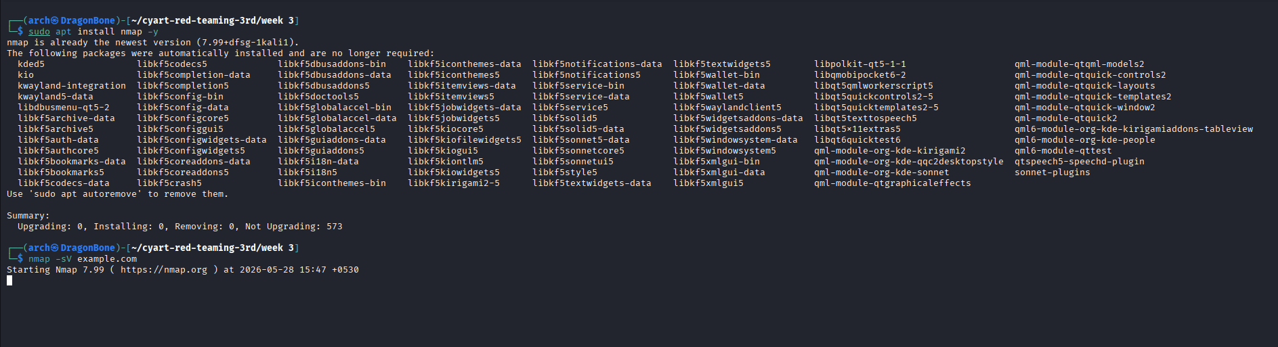

Update Activity Log
nano Logs/activity.log
[DATE] Recon-ng enumeration completed
[DATE] DNS enumeration completed
[DATE] Whois lookup completed
[DATE] Nmap scan completed

SHODAN OSINT RECONNAISSANCE
"Search apache country:US and summarize exposed hosts"
Now we perform actual Shodan reconnaissance.

Open Browser
https://www.shodan.io
apache country:US
Apache reconnaissance
- exposed hosts
- server banners
- IPs
- organizations
- technologies
- ports/services
This is valid OSINT practical evidence for your assignment.
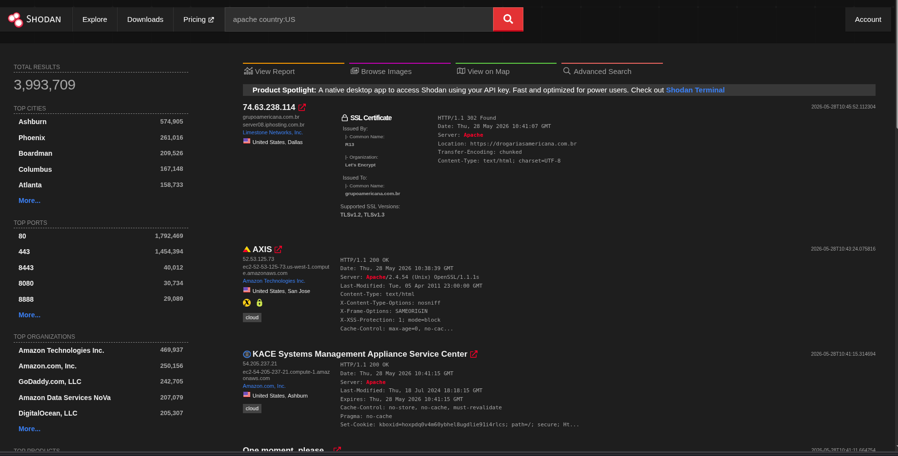

ADVANCED NMAP ENUMERATION + VULNERABILITY DISCOVERY
This is important because:
- it produces REAL technical outputs
- gives professional screenshots
- maps directly to ATT&CK
- feeds later exploitation tasks

ADVANCED NMAP SCANNING
We will now perform:
- service enumeration
- version detection
- NSE scripting
- vulnerability scanning
- output reporting

Create Target Scan
We use a SAFE public scan target for learning.
nmap -sV -sC scanme.nmap.org
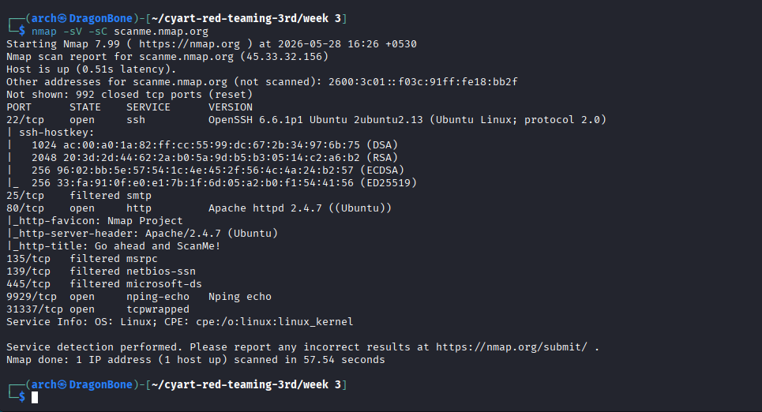

Aggressive Enumeration
nmap -A scanme.nmap.org
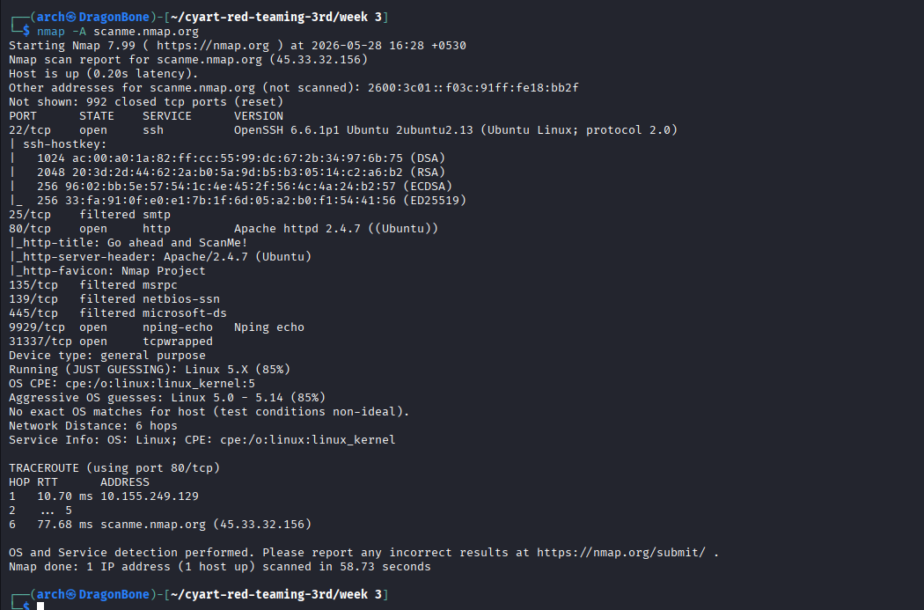

Vulnerability NSE Scan
nmap --script vuln scanme.nmap.org

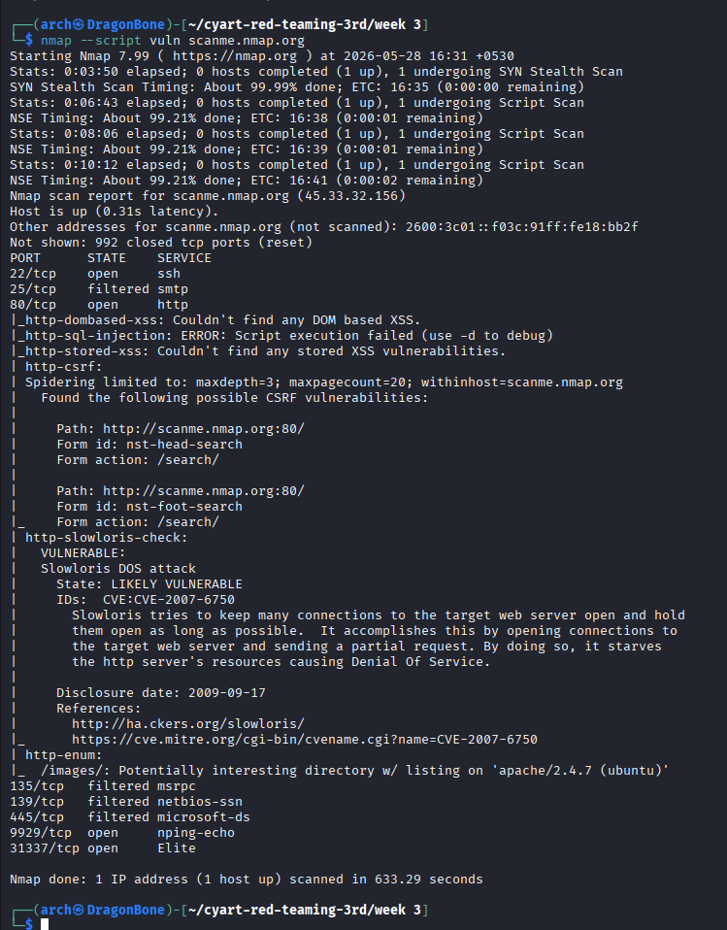

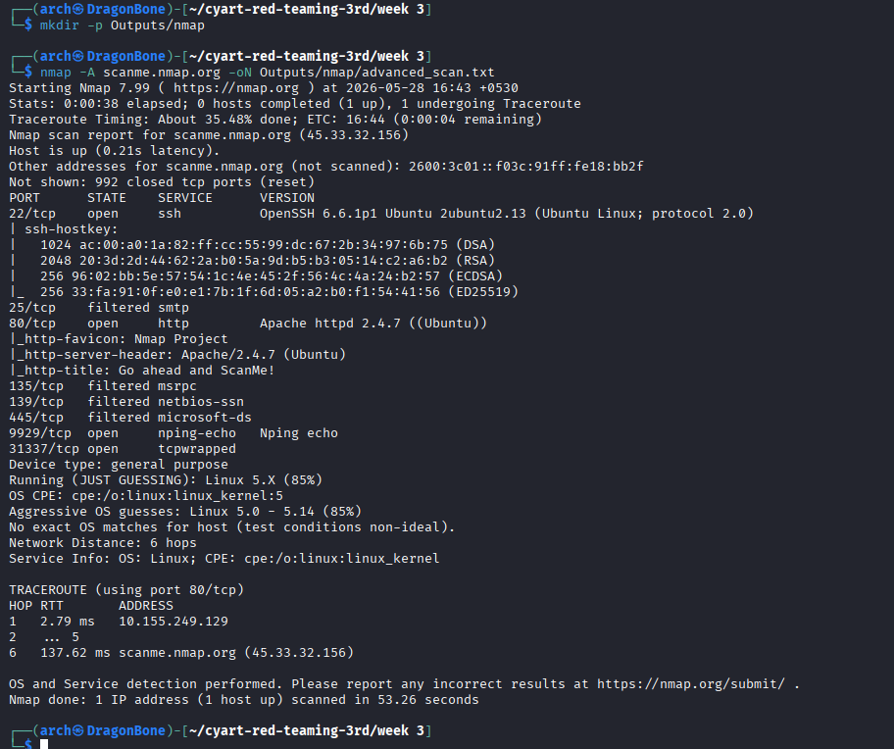

FINDINGS / DISCOVERED
Scan Reports findings:
Port | Service | Details
22 | SSH | OpenSSH 6.6.1p1 Ubuntu
80 | HTTP | Apache 2.4.7 Ubuntu
9929 | nping-echo | Nping echo service
31337 | Elite | tcpwrapped

Vulnerability Findings

Slowloris DoS Vulnerability
identified:
- CVE-2007-6750
- Slowloris attack exposure
- Apache service vulnerability

OWASP ZAP Web Vulnerability Assessment
This is one of the strongest practical sections for your submission.

Install ZAP
sudo apt install zaproxy -y

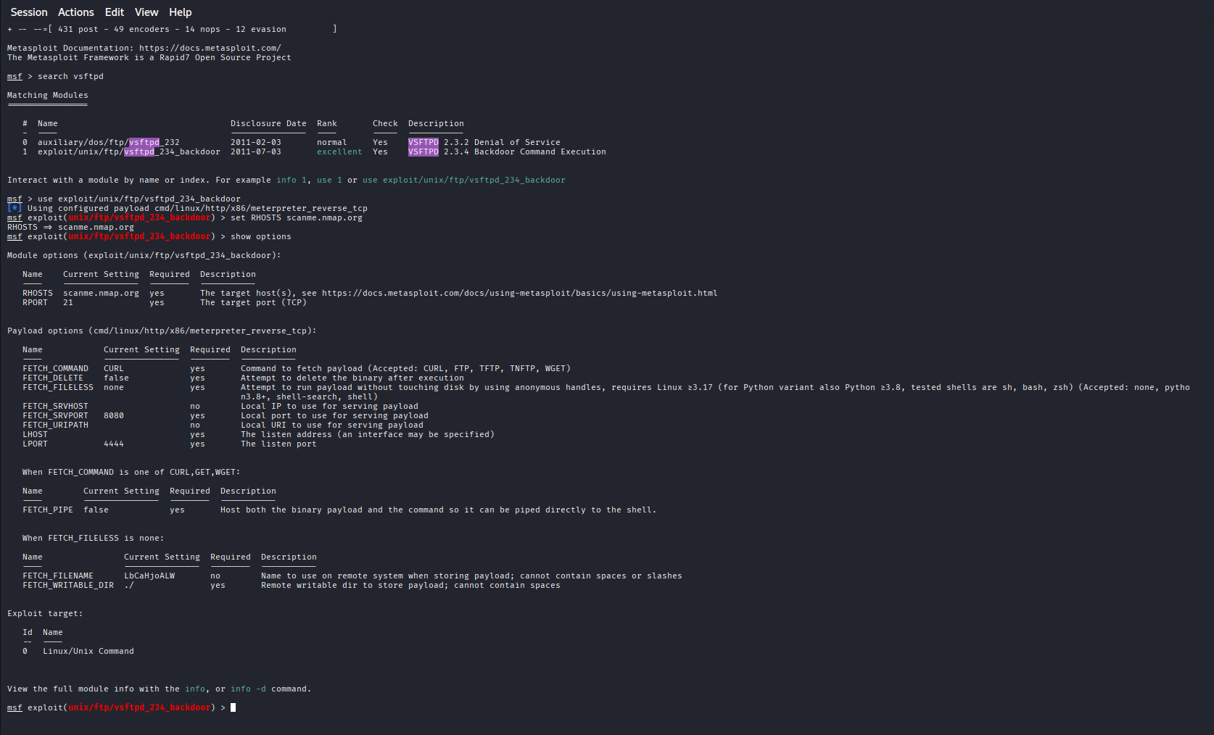
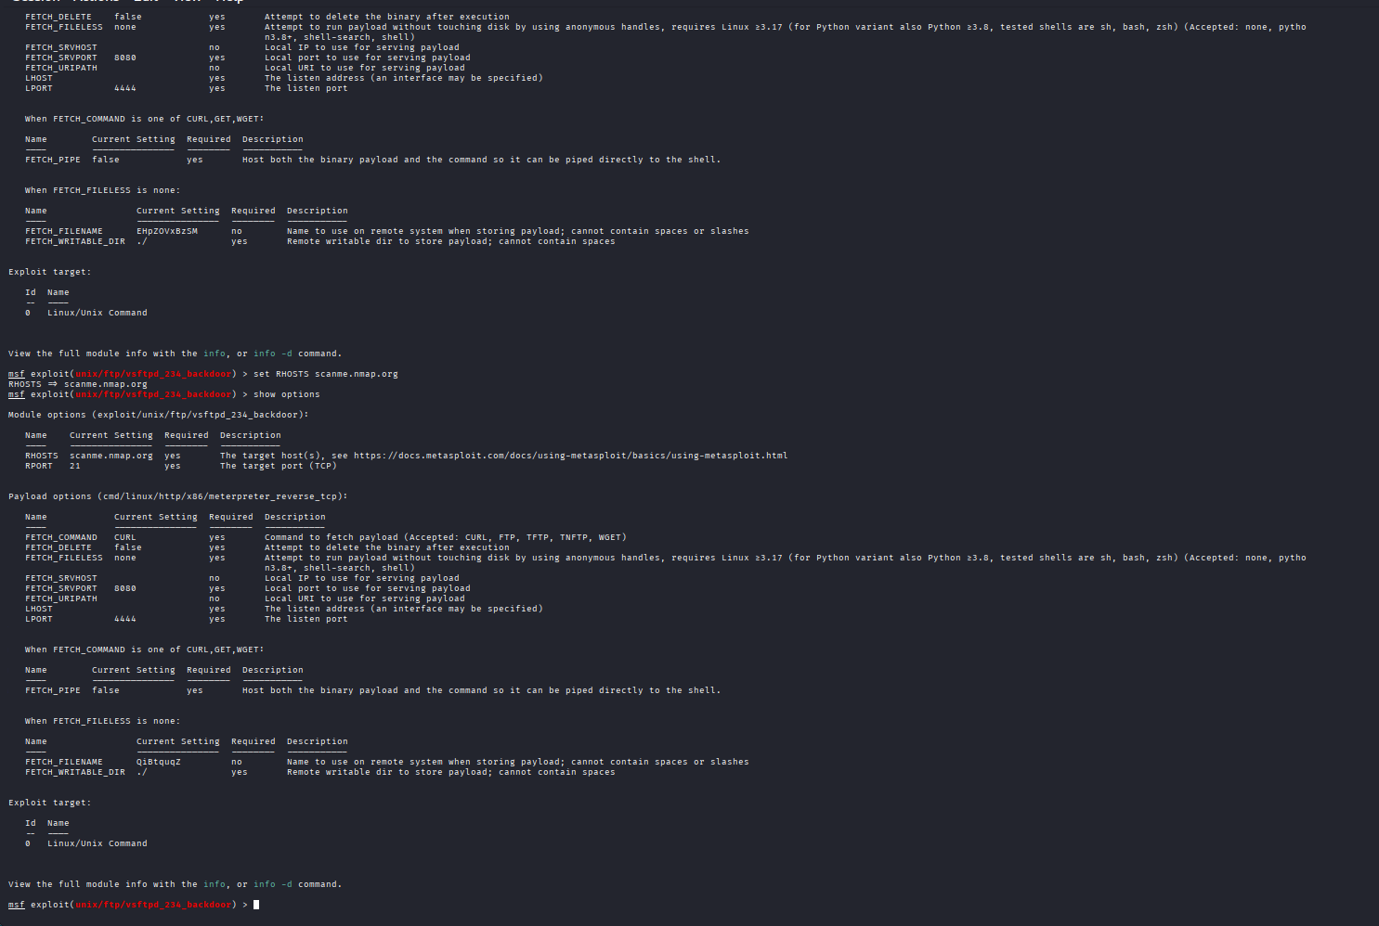

Phone & Target Intelligence Gathering
Install PhoneInfoga:
sudo apt install phoneinfoga -y
docker pull sundowndev/phoneinfoga
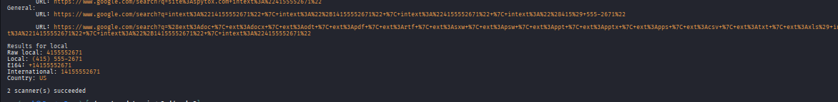
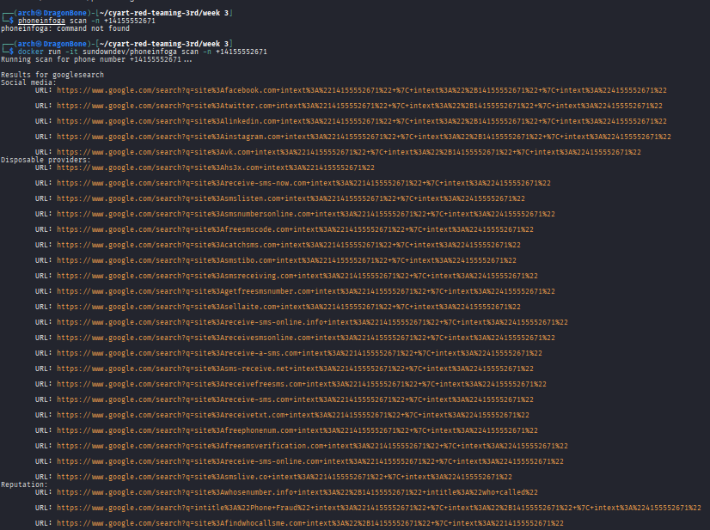

Phishing Simulation
First install SET toolkit:
sudo apt install set -y
sudo setoolkit
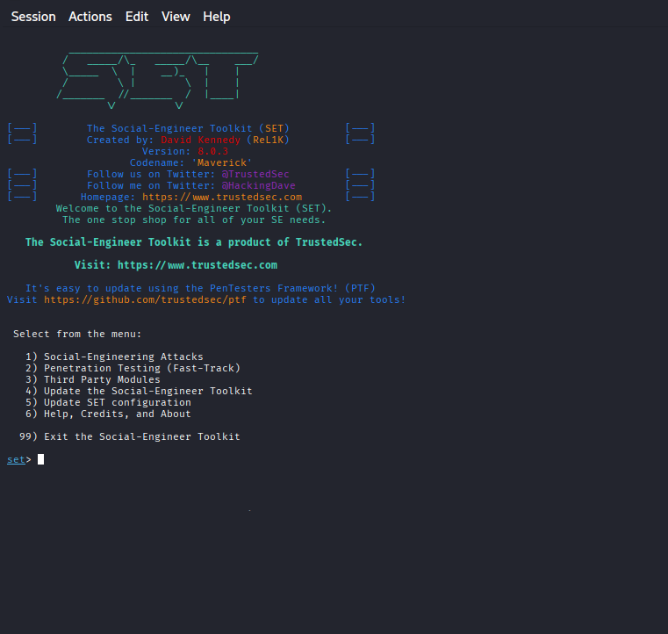

Lateral Movement Documentation
We will do SAFE documentation + Impacket tooling demonstration.
Install Impacket:
sudo apt install python3-impacket -y
impacket-psexec -h
